May 2021
Financial Services and General Office COVID-19 Reopening Guide
The COVID-19 outbreak has impacted all industry segments in 2020 and now it has extended into 2021. (Insert Company Name) leadership team has reorganized our daily business operations to ensure the safety of our team members, contract labor and visitors. One misstep can lead to the quick spread of COVID-19, jeopardizing the well-being of our company, reputation and valued resources.
To help slow the spread of COVID-19 and safeguard our business operations, the leadership team has created an action plan for responding to COVID-19 pandemic and assist all in getting back to business. This plan is based on guidance from the Centers for Disease Control and Prevention (CDC), local health department and the Occupational Safety and Health Administration (OSHA). The plan highlights the responsibilities of our employees and outlines the steps that each team member needs to take to address COVID-19 loss prevention.
Responsibilities
Our leadership team and our team members all play a crucial role in assuring our success in safely reopening our business operations. The following is a breakdown of the responsibilities for all of our team members, our contract labor, and our visitors.
Leadership Team
The leadership team has familiarized itself with all details within the action plan. Management is prepared to demonstrate the desired path toward minimizing the spread of COVID-19 by adhering to the guidance prescribed in this plan. This involves practicing social distancing, good personal hygiene, enforcing appropriate personal protective equipment (PPE) use, and guiding other team members and visitors towards practicing desired loss prevention practices.
Team Members
All employees play a critical role in our COVID-19 loss prevention efforts. To protect everyone in at work environment, our COVID-19 Prevention Team has adopted several best practices that all (Insert Company Name) employees must follow, namely:
- Understand the signs and symptoms of COVID-19 and stay home if you are feeling sick: Any employees who are experiencing symptoms of COVID-19 (e.g., fever, cough, shortness of breath, sore throat, runny nose, body aches, chills or fatigue) should stay home. Individuals experiencing such symptoms should also be instructed to consult guidance from their personal physician on seeking medical care. Employees should notify their direct report or Human Resources of any symptoms and/or exposures to positive COVID-19 individuals.
- Practice good hygiene: All employees should clean their hands often, either with an alcohol-based hand sanitizer or soap and water. Hand sanitizers should contain at least 60%-95% alcohol, and employees should wash their hands with soap for at least 20 seconds. In addition, employees should avoid touching their face and cough into their arm.
This material is for informational purposes and is not intended to be exhaustive nor should any discussions or opinions be construed as legal advice. Contact your broker for insurance advice, tax professional for tax advice, or legal counsel for legal advice regarding your particular situation. USI does not accept any responsibility for the content of the information provided or for consequences of any actions taken on the basis of the information provided. © 2021 USI Insurance Services. All rights reserved.

- Practice social distancing: Social distancing is the practice of deliberately increasing the 6-foot physical space between people to avoid spreading illness. Social distancing will continue within all the common areas of our buildings (conference center rooms, elevators, corridors, lobby areas, restrooms, work areas, et) shared office and cubicle spaces. Management has installed physical barriers in between cubicles where 6-foot separations cannot be maintained.
- PPE: Although the CDC has lifted the face mask requirement for individuals who have been vaccinated, all employees are still required to wear face masks while within our work environments in which 6-foot separations cannot be maintained. The mandatory use of face masks is required in all common areas, including bathrooms, elevator carriages, corridors, break rooms, and conference rooms. Face masks are not required at your desk if you can practice the appropriate 6-foot distancing and barrier walls separates adjoining workers. Protective gloves may be required for tasks in which building maintenance and mailroom personnel encounter common public areas/machinery/etc.
Pandemic Prevention Team
The leadership team has organized a Pandemic Prevention Team (PPT), which includes representatives from Business Administration, Facilities Management, Maintenance Management, Labor Relations, and Operations. This team will oversee the workplace protocols to minimize our exposures to COVID-19. The team is assigned the following roles:
- Business Administration — Business Administration will chair the PPT activities and direction. They will be responsible for working with key stakeholders to manage this action plan.
- Facilities Management — Either the building owners Property Manager or our Operations Manager will work with the PPT in recommending and developing protocols to ensure the wellness of all employees on their properties. They will be tasked with the development and overseeing procedures for screening personnel prior to entrance into our business environment as well as working with Labor Relations in establishing protocol if an employee exhibits symptom of a possible infection.
- Maintenance Management — The Property Maintenance Managers will manage logistics related to daily and periodic sanitation and disinfection efforts. Their responsibilities include ensuring that routine cleanings are completed and that the necessary cleaning supplies are readily available. They will be responsible to assure all third-party maintenance contractors hired to work our facilities abide by our loss prevention practices.
- Labor Relations — The Human Resources Manager will work directly with the Operations manager to managing all pandemic-related communications. They will work closely with the PPT Business Administrator to ensure all COVID-19 related communications are current and communicated effectively to our work force.
- Vaccination and/or COVID-19 Testing — The leadership team and the PPT encourages our team members to become vaccinated when possible. COVID-19 tested and/or Vaccination during company work hours will be allowed and held in confidence. Those employees who are not willing to become vaccinated will not be allowed to enter the workplace and will be asked to work from an “at-home work setting” for the time being.

Definitions
“COVID-19” means coronavirus disease, an infectious disease caused by the severe acute respiratory syndrome coronavirus 2 (SARS-CoV-2).
“COVID-19 case” means a person who:
- Has a positive “COVID-19 test” as defined in this section.
- Is subject to COVID-19-related order to isolate issued by a local or state health official; or
- Has died due to COVID-19, in the determination of a local health department or per inclusion in the COVID-19 statistics of a county.
A person is no longer a “COVID-19 case” in this section when a licensed health care professional determines that the person does not have COVID-19, in accordance with recommendations made by the California Department of Public Health (CDPH) or the local health department pursuant to authority granted under the Health and Safety Code or title 17, California Code of Regulations to CDPH or the local health department.
“COVID-19 exposure” means being within six (6) feet of a COVID-19 case for a cumulative total of 15 minutes or greater in any 24-hour period within or overlapping with the “high-risk exposure period” defined by this section. This definition applies regardless of the use of face coverings.
“COVID-19 hazard” means exposure to potentially infectious material that may contain SARS-CoV-2, the virus that causes COVID-19. Potentially infectious materials include airborne droplets, small particle aerosols, and airborne droplet nuclei, which most commonly result from a person or persons exhaling, talking or vocalizing, coughing, sneezing, or procedures performed on persons that may aerosolize saliva or respiratory tract fluids, among other things. This also includes objects or surfaces that may be contaminated with SARS-CoV-2.
“COVID-19 symptoms” means fever of 100.4 degrees Fahrenheit or higher, chills, cough, shortness of breath or difficulty breathing, fatigue, muscle or body aches, headache, new loss of taste or smell, sore throat, congestion or runny nose, nausea or vomiting, or diarrhea, unless a licensed health care professional determines the person’s symptoms were caused by a known condition other than COVID-19.
“COVID-19 test” means a viral test for SARS-CoV-2 that is:
- Approved by the United States Food and Drug Administration (FDA) or has an Emergency Use Authorization from the FDA to diagnose current infection with the SARS-CoV-2 virus; and
- Administered in accordance with the FDA approval or the FDA Emergency Use Authorization as applicable.
“Exposed workplace” means any work location, working area, or common area at work used or accessed by a COVID-19 case during the high-risk period, including bathrooms, walkways, hallways, aisles, break or eating areas, and waiting areas. The exposed workplace does not include buildings or facilities not entered by a COVID-19 case.
“Face covering” means a tightly woven fabric or non-woven material with no visible holes or openings, which covers the nose and mouth.
“High-risk exposure period” means the following time period:
- For persons who develop COVID-19 symptoms: from two (2) days before they first develop symptoms until 10 days after symptoms first appeared, and 24 hours have passed with no fever, without the use of fever-reducing medications, and symptoms have improved; or
- For persons who test positive who never develop COVID-19 symptoms: from two (2) days before until 10 days after the specimen for their first positive test for COVID-19 was collected.
Property Operating Protocols
To keep our staff, third-party contractors, and visitors safe from the spread of COVID-19, the leadership team requires the following workplace protective measures:
General Safety Policies
- This policy and procedure will be communicated to all (Insert Company Name) employees. Our communication regarding the COVID-19 plan will include:
  - A description of the COVID-19 exposure routes along with related symptoms and personal loss prevention measures to avoid the virus
  - The policies and procedures that management has adopted to identify potentially infected personnel, the policies and procedures involved with our loss prevention efforts, and the process of managing a COVID-19 infection at the workplace.
- Employees can voice concerns COVID-19 concerns directly to the Labor Relations/Human Resources Department without any fear of reprisal.
- Access to hand-washing stations and alcohol-based hand sanitizers will be located throughout our work areas and be provided to employees and visitors within the building common areas.
- The PPT will place posters that encourage hand hygiene to help stop the spread of COVID-19 at the building entrances, within lobby areas, and within the elevator banks.
- The PPT will limit the number of occupants allowed within our buildings at any one time to meet local Health Department distancing requirements.
- The PPT is aware that some employees may be at higher risk for serious illness, such as older adults and those with chronic medical conditions. To safeguard employees at-risk, we will take steps to ensure they have minimal contact with others, and in some cases, offer these employees an ongoing at-home work option.
- Management may implement an at-home work contingency plan for selected job tasks should a building COVID-19 incident occur.
- All managers will ensure there is a minimum of 6 feet of space between all desks and workspaces. If adjacent work environments cannot meet the minimum 6-foot distancing, permanent plexiglass barriers may be introduced.
- Employees and visitors are always required to wear face masks inside our buildings and while on our exterior grounds.
- Management will modify the flow of traffic to minimize potential close contact with others within common areas.
- Management will provide tissues and no-touch disposal receptacles within all restrooms.
- Operations will encourage the use of digital files and e-mail correspondences so staff will not have to exchange frequently touched paper documents.
- Employees will require the PPT’s approval for hosting meetings and gatherings. All meetings and gatherings should first:
  - Consider using videoconferencing or teleconferencing when possible, for work-related meetings and gatherings. When videoconferencing or teleconferencing is not possible, hold meetings in open, well-ventilated spaces.
  - Consider canceling or postponing large work-related meetings or gatherings that can only occur in-person.
  - All employees will refrain from sharing equipment. In instances where this is unavoidable, the PPT will provide alcohol-based wipes and other cleaning materials that employees can use to clean equipment.
- All employees should clean and disinfect frequently touched surfaces within their areas, including workstations, copy machines, door handles, tables and countertops on a regular basis.
- All employees should practice proper hand hygiene. Wash your hands regularly with soap and water for at least 20 seconds. An alcohol-based hand sanitizer containing at least 60% alcohol can also be used. All individuals should clean their hands:
  - Before eating food
  - After using the restroom
  - After blowing their nose, coughing or sneezing
  - After putting on, touching or removing face masks
  - Before and after work shifts
  - Periodically throughout the day
  - Before and after work breaks
- All employees should avoid contact with others whenever possible (e.g., handshakes, fist pumps, elbow touch, etc.).
- All employees should also only enter and exit designated areas and follow common area foot travel signage to avoid close human contact.
- All employees should follow any posted signage regarding COVID-19 social distancing practices within the building elevators, stairwells and corridors.
Protocols for Contractors and Visitors
To ensure safety within our office locations and to minimize the exposure to spreading the COVID-19 virus, all contractors and visitors will be asked to:
- Refrain from entering the premises if they are experiencing COVID-19 symptoms (e.g., fever, cough or shortness of breath). Potentially sick individuals should follow CDC-recommended steps. All potentially sick individuals should not return to our place of business until the CDC criteria to discontinue home isolation are met, in consultation with health care providers and state and local health departments.
- All contractors and visitors will be screened prior to entering all our office locations. Targeted questions regarding all potential building occupants concerning their current health before they enter our workspace will be answered on-line prior to entry or at our building/suite entrance. If anyone answers questions in a negative manner or exhibits COVID-19 symptoms, the individuals may be denied building access and ask to leave the premises and not return to our site until they have met the local Health Department and OSHA work force re-enter baselines.
- All contractors, and visitors will be forehead temperature scanned at within the lobby prior to entry into our workplace. The screening devices will not allow any individual with a forehead temperature scan of 100.4 or higher to enter the premises.
Cleaning and Disinfecting Desired Practices
The PPT will assure that all employees adhere to the local Department of Health and OSHA guidelines for preventing COVID-19 exposures. The following desired safe practices should be carried onto each occupied building space when applicable:
Surfaces and equipment will be disinfected at the end of each shift, before and after use, or—for frequently touched items—multiple times a day. The following items will be cleaned regularly:

- Door handles and push plates
- Restrooms
- Handles on all equipment doors
- Handles on beverage dispensers
- Refrigerator and freezer handles
- Sink handles
- Soap dispenser push plates
- Towel dispenser push plates
- Trash receptacle touch points
- Facilities cleaning tools
- Telephones
- Computers
- Office cabinet handles
- Break room tables and chairs
- Display screens on equipment
- Thresholds and hand railings
- Office push carts
- Counters and other surface
- Building third-party contractors responsible for cleaning should be provided with the appropriate protective equipment. Cleaning should be completed using CDC-recommended products, including:
  - Environmental-Protection-Agency-registered household disinfectants
  - Alcohol solutions with at least 60% alcohol
  - Diluted household bleach solutions (if appropriate for the surface)
  - Trash will be collected from the workplace regularly. Those collecting trash will be instructed to wear nitrile, latex or vinyl gloves.
  - Hand sanitizer dispensers will be refilled frequently.
- When an individual within our work environment has tested positive for COVID-19 and had contact with individuals within our work environment, deep cleaning will be triggered, and either the Building Owner or our Facilities management Group. The PPT will ensure areas in which the individual worked are cleaned thoroughly. The PPT will initiate an exposure investigation process. In regard to deep-cleaning practices:
  - The PPT will identify an approved external company to complete a deep cleaning of the facilities. This external company will be equipped with the proper training, permits and cleaning equipment to complete the task.
  - Facilities Management and Maintenance Management will coordinate and supervise deep-cleaning efforts to ensure:
    - There is a specific plan and strategy in place, and that plan accounts for all machinery, equipment, common areas, tools and offices.
    - Authorized individuals are the only ones allowed access to the site during the deep cleaning.
    - Employees are aware of deep-cleaning practices.
    - The company contracted to perform the deep cleaning uses the appropriate PPE during the process and disposes of potentially contaminated items properly.
Exposure Situations
The PPT has a plan in place to identify potential areas where the virus can spread within our workplace building common areas and has a plan to respond to situations when employees exhibit symptoms of or test positive for COVID-19.
Identification and Evaluation of COVID-19 Hazards
- An initial workplace inspection will be completed to identify all potential interaction areas, common areas, frequently touched areas, et, to establish preventative measures and sanitizing practices to prevent the potential spread of
COVID-19.
- Common areas of exposure identified within the initial inspection will be turned into a “hit list” of areas to be sanitized daily by our facilities cleaning service.
- The PPT will require our third-party HVAC contractors to clean and disinfected our air filter system on a regular basis.
- All indoor work environments will be evaluated to determine how to maximize the quantity of outdoor air and increase the air exchange rate.
- Periodic COVID-19 program inspections will be completed to audit the program efficiency, loss prevention measures, and to ensure compliance with the applicable regulatory agencies’ guidelines.
Individuals Who Exhibit Symptoms of COVID-19 Before Entering the Facility
- If a (Insert Company Name) employee, visiting contractor or guest exhibits any symptoms related to COVID-19 at any of our properties, the entrance assessor will immediately ask the individual to leave our place of business.
- If the potentially infected individual remains on-site, the PPT will provide the individual with a face mask and gloves and will ask the individual to be seated in a designated isolation room for further evaluation by the local fire department.
- If COVID-19 symptoms are confirmed, the individual will be asked to go home, isolate, and speak with their health care provider. The PPT will ensure that the individual is able to get home safely before being dismissed. If, after an evaluation, the individual is not exhibiting COVID-19 symptoms, they may enter the workplace at the discretion of the PPT.
- If an individual tests positive for COVID-19, the PPT will notify the local Health Department of the exposure.
- The PPT will take the following actions if a confirmed case of COVID-19 is identified within anyone of our properties:
  - Incident tracking to include the date and time the COVID-19 case was last present, and if possible, the date of the positive COVID-19 test diagnosis, and the date the COVID-19 case first had one or more COVID-19 symptoms, if any were experienced.
  - Determination on who may have been exposed to the infected individual. This will require an evaluation of the activities of the COVID-19 case and all locations at the workplace that may have been visited by the infected individual during the high-risk exposure period.
  - Provide notice of the potential COVID-19 exposure, within one business day, in a way that does not reveal any personal identifying information of the COVID-19 case, to all individuals who may have been exposed to the infected individual.
  - Management will offer COVID-19 testing at no cost to a potentially infected individual who was exposed within our building common areas.
  - All employees of (Insert Company Name) will be offered testing at no cost if an employee exhibits symptom during their working hours and to all employees who had potential COVID-19 exposure within the workplace.
  - Management will investigate whether any workplace conditions could have contributed to the risk of COVID-19 exposure and what additional preventative measures could be done to reduce exposure to COVID-19 hazards.
  - Human Resources will assure that all personal information of COVID-19 cases or persons with COVID-19 symptoms will remain confidential. The PPT will be providing all positive COVID-19 cases to the Local Health Department.
(Insert Company Name) Employee Self-Quarantining and Return to Work
(Insert Company Name) employees who test positive for COVID-19 or believe they have been infected will be instructed to follow the advice of a qualified medical professional and self-quarantine. When self-quarantining, employees should:
- Stay away from other people in their home as much as possible, staying in a separate room and using a separate restroom if available.
- Not allow visitors.
- Wear a face mask if they must be around people.
- Avoid sharing household items, including drinking cups, eating utensils, towels and bedding.
- Clean high touch surfaces daily.
- Continue monitoring their symptoms, calling their health care provider if their condition worsens.
Notably, all (Insert Company Name) employees who are symptomatic or who have tested positive should not return to work until the conditions outlined in the table below are met:
Return to Work Considerations
Employee was symptomatic but was not tested  for COVID-19 | Employee was tested for COVID-19
The employee may return to work if:  - They have not had a fever for at least 72 hours and have not used fever-reducing medication during that time.  - Coughs and other symptoms have improved.  - Seven (7) days have passed since they first experienced symptoms. | The employee may return to work if:  - They no longer have a fever.  - Coughs and other symptoms have improved.  - They have received two (2) negative COVID-19 tests in a row. Documentation is required.
OSHA Recordkeeping and Reporting
The PPT will adhere to OSHA-mandated requirements and the state Workers’ Compensation Laws as they relate to recording and reporting COVID-19 cases. Reference the following COVID-19 OSHA Reporting and Recordkeeping
Flow Charts.

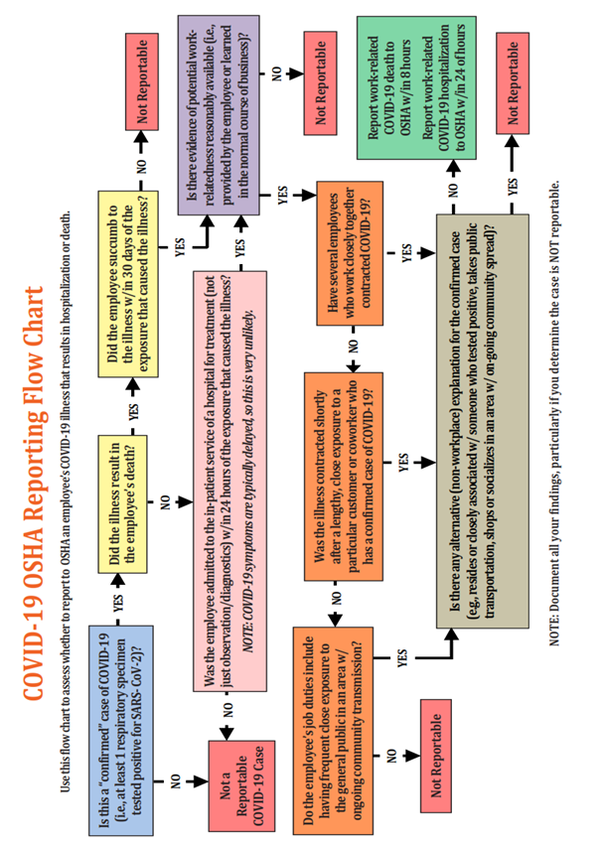

Source: Conn Maciel Carey LLP
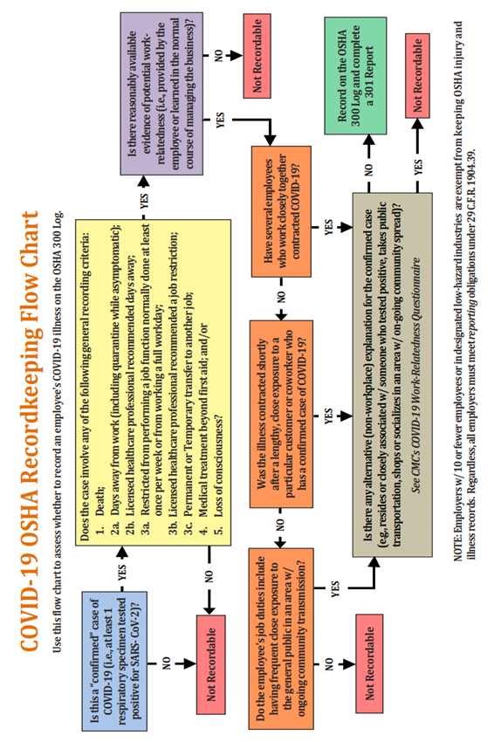
Source: Conn Maciel Carey LLP

